**ALGORITHM AND DATA STRUCTURE PRACTICUM**

**MODULE 3**

**COLEETIONS, ARRA AND LINKED STRUKTURES**



**CREATED BY :**

**KURNIAWAN BAGASKARA**

**L200214253**

**INFORMATICS STUDY PROGRAM**

**FACULTY OF COMMUNICATION AND INFORMATION SCIENCE**

**MUHAMMADIYAH SURAKARTA UNIVERSITY**

**Latihan 3.1**

>>> A = [ [2,3], [5,7] ]

>>> A[0][1]

3

>>> A[1][1]

7

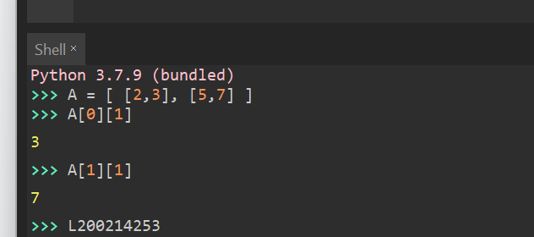

**Latihan 3.2**

>>> B = [ [ 0 for j in range (3)] for i in range(3) ]

>>> B

[[0, 0, 0], [0, 0, 0], [0, 0, 0]]

>>> L200214253

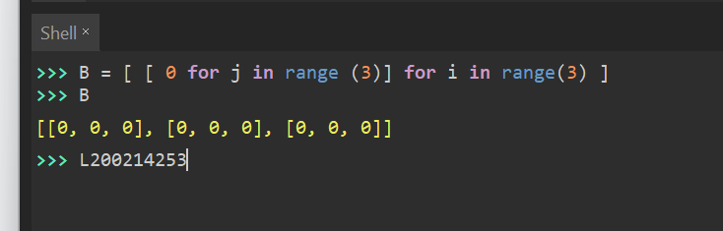

**Soal 1.**

A = [[1,2],[3,4],[5,6]]

B = [[7,8],[9,10]]

C = [[3,6],[5,2]]

#Nomor 1A

class matriks (object):

def cetakmatriks(self, matriks):

for i in matriks:

print(i)

def cekkonsisten(self, matriks):

if len(matriks[0]) == len(matriks):

print ("matriks konsisten")

else:

print ("matriks tidak konsisten")

x = matriks()

x.cetakmatriks(A)

print(x.cekkonsisten(A))

y = matriks()

y.cetakmatriks(B)

print(y.cekkonsisten(B))

#Nomor 1B

def ordo(matriks):

return ("Ordo matriks = "+str(len(matriks))+" x "+str(len(matriks[0])))

#Nomor 1C

def jumlah(matriks1, matriks2):

if ordo(matriks1) == ordo(matriks2):

for x in range(0, len(matriks1)):

for y in range(0, len(matriks1[0])):

print (matriks1[x][y] + matriks2[x][y],' '),

print()

else:

print("Matriks tidak sesuai")

#Nomor 1D

def kali(m,n):

a = 0

x,y = 0,0

for i in range(len(m)):

x += 1

y = len(m[i])

v,w = 0,0

for i in range(len(n)):

v += 1

w = len(n[i])

if (y == v):

print ("Bisa Dikalikan")

vwxy = [[0 for j in range(w)] for i in range(x)]

for i in range(len(m)):

for j in range(len(n[0])):

for k in range(len(n)):

vwxy[i][j] += m[i][k] * n[k][j]

print (vwxy)

else:

print("Tidak memenuhi syarat")

kali(A,B)

kali(B,C)

#Nomor 1E

def determinan(p, total = 0):

x = len(p[0])

z = 0

for i in range(len(p)):

if (len(p[i]) == x):

z += 1

if (z == len(p)):

if (x == len(p)):

indices = list(range(len(p)))

if len(p) == 2 and len(p[0]) == 2:

val = p[0][0] * p[1][1] - p[1][0] * p[0][1]

return val

for fc in indices:

pq = p

pq = pq[1:]

height = len(pq)

for i in range(height):

pq[i] = pq[i][0:fc] + pq[i][fc+1:]

sign = (-1) ** (fc % 2)

sub_det = determinanHitung(pq)

total += sign * A[0][fc] * sub_det

else:

return "Tidak bisa dihitung, bukan matriks bujur sangkar"

else:

return "Tidak bisa dihitung, bukan matriks bujur sangkar"

return total

print('Kurniawan Bagaskara')

print('L200214253')

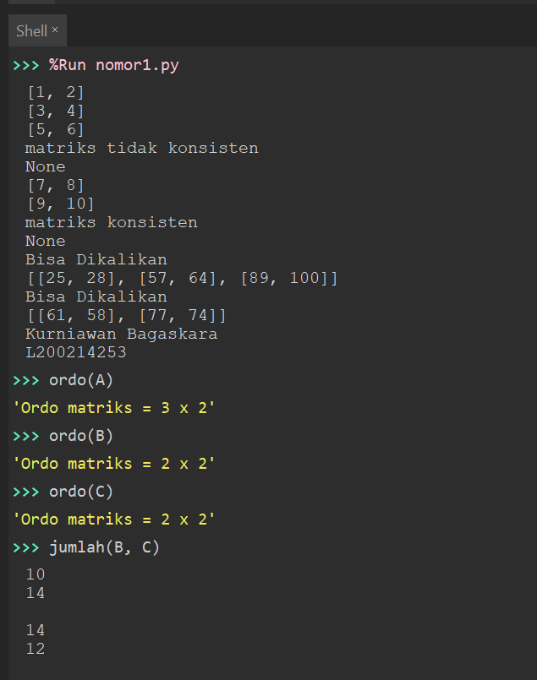

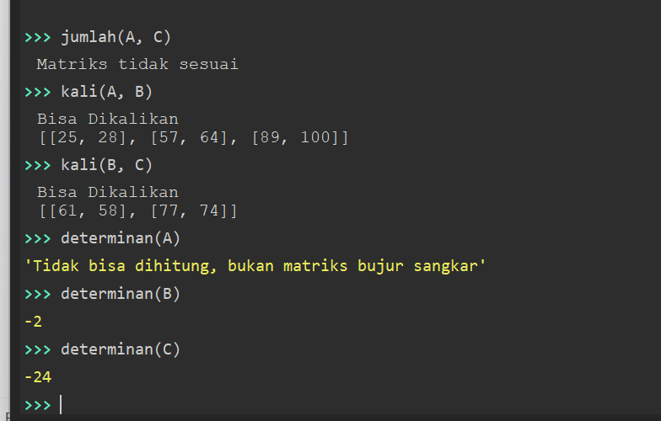

**Soal 2.**

#Nomor 2A

def buatNol(n, m=None):

if (m == None):

m = n

print ("Membuat matriks 0 dengan ordo "+str(n)+" x "+str(m))

print ([[0 for j in range(m)] for i in range(n)])

#Nomor 2B

def buatIdentitas(m):

n = m

print("Membuat matriks identitas dengan ordo "+str(n)+" x "+str(n))

matriks = [[1 if j == i else 0 for j in range(m)] for i in range(n)]

print(matriks)

print('Kurniawan Bagaskara')

print('L200214253')

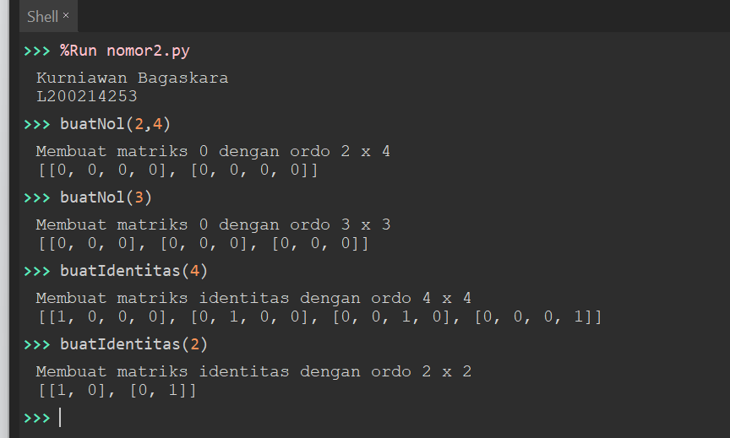

**Soal 3.**

class Node:

def __init__(self, data):

self.data = data

self.next = None

class LinkedList:

def __init__(self):

self.head = None

def tambahDepan(self, new_data):

new_node = Node(new_data)

new_node.next = self.head

self.head = new_node

def tambahAkhir(self, data):

if (self.head == None):

self.head = Node(data)

else:

current = self.head

while (current.next != None):

current = current.next

current.next = Node(data)

return self.head

def tambah(self,data,pos):

node = Node(data)

if not self.head:

self.head = node

elif pos == 0:

node.next = self.head

self.head = node

else:

prev = None

current = self.head

current_pos = 0

while (current_pos < pos) and current.next:

prev = current

current = current.next

current_pos += 1

prev.next = node

node.next = current

return self.head

def hapus(self,posisi):

if self.head == None:

return

temp = self.head

if posisi == 0:

self.head = temp.next

temp = None

return

for i in range(posisi - 1):

temp = temp.next

if temp is None:

break

if temp is None:

return

if temp.next is None:

return

next = temp.next.next

temp.next = None

temp.next = next

def cari(self,x):

current = self.head

while current != None:

if current.data == x:

print(x, "Apakah ada dalam data?")

return True

current = current.next

print(x,"Apakah ada dalam data?")

return False

def display(self):

current = self.head

while current is not None:

print(current.data, end = ' ')

current = current.next

print('Kurniawan Bagaskara')

print('L200214253')

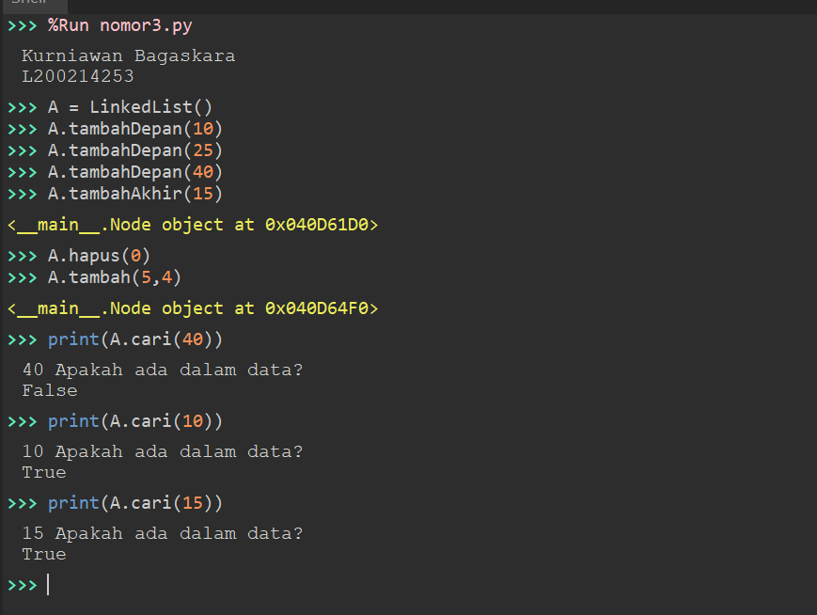

**Soal 4.**

class Node:

def __init__(self, data):

self.data = data

self.prev = None

class DoublyLinkedList:

def __init__(self):

self.head = None

def awal(self, new_data):

print("Menambah pada awal ",new_data)

new_node = Node(new_data)

new_node.next = self.head

if self.head is not None:

self.head.prev = new_node

self.head = new_node

def akhir(self,new_data):

print("Menambah pada akhir ",new_data)

new_node = Node(new_data)

new_node.next = None

if self.head is None:

new_node.prev = None

self.head = new_node

return

last = self.head

while(last.next is not None):

last = last.next

last.next = new_node

new_node.prev = last

return

def printList(self,node):

print("\nDari depan :")

while (node is not None):

print (" %d "%(node.data))

last = node

node = node.next

print ("\nDari belakang :")

while (last is not None):

print (" %d "%(last.data))

last = last.prev

print('Kurniawan Bagaskara')

print('L200214253')

